2021
LAKESMART HOMEOWNER QUESTIONNAIRE

Primary Homeowner Name(s) (first and last):

Site Street Address, Town, Zip:

Phone Number: Summer:__________________ Winter:__________________

Email Address:
Preferred Mailing Address (if different from site address):
- Has this property been previously evaluated? YES NO
- What year was the home built? ____ 3. How long have you owned the home? _______
- Do you live here year-round? YES NO
- Do you belong to a road association? (if so, please list)
- Please describe (or attach a drawing) where the septic system and leach field are on the property. (If you do not know, you can visit lakes.me/septic for a link to the state’s searchable database of septic permit applications (dating back to 1974)).

- Do you follow a professionally recommended septic pumping schedule? YES NO
- How often do you use herbicides and pesticides?
NEVER RARELY (once or twice/year) OFTEN (three or more times/year)
- How often do you use fertilizer?
NEVER RARELY (once or twice/year) OFTEN (three or more times/year)
- Where is your lawn mower blade set? HIGH MEDIUM LOW
- May we post your name/lake on our website for participating in LakeSmart? YES NO
- May we use photos for teaching or promotion (no names/addresses shared)? YES NO
- May we share your contact information with other local conservation organizations looking to assist or engage lakefront homeowners (regional watershed organizations or lake associations, watershed survey organizers, local land trusts, etc.)? YES NO
- Do you want to be present for the LakeSmart evaluation? (Suggestions for your property will be included in the written report provided to you after the evaluation, so your presence is not required.) YES NO
- Approximate total water frontage owned: _____________feet
- Approximate water frontage in front of developed area: ______________feet

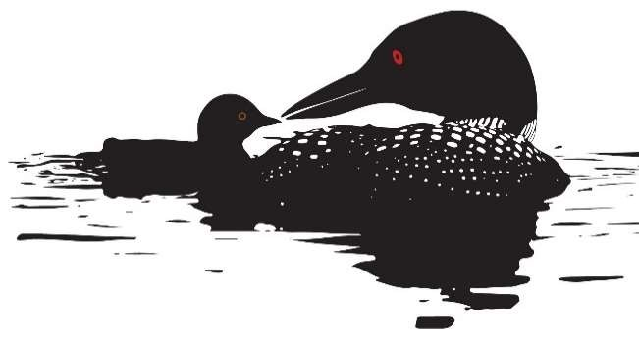
LOON SMART MERIT AWARD
Maine Lakes has partnered with Maine Audubon to recognize homeowners whose practices protect loons and their habitat. Standards include both land use on the property as well as the practices and commitments of property owner(s).
- Loons are visual predators, so minimizing runoff and siltation to maintain water quality is critically important to their ability to fish and find food for their young.
- Loons are sensitive to disturbance, both on their lakeside nests and on the water. Being aware of where loons are and keeping a good distance away, especially in canoes and kayaks in wetlands and shallow water will help minimize stress.
- Loons nest right next to the water, where boat wakes can flood the nest and wash the eggs away. Keeping to headway speed as required in the 200’ Boater Safety Zone will reduce that risk.
- Loons can pop up unintentionally in the path of oncoming boats. In fact, boat strikes are thought to be one of the leading causes of adult loon mortality in Maine. Watching for loons while boating can help reduce this risk.
- Predators including skunks and raccoons can make quick work of loon eggs. Reducing attractants to keep these predators away from nesting areas will help improve overall nesting success.
- The ingestion of lead tackle and entanglement of loons in monofilament line are ever present problems for loons in Maine. Fish lead free and properly dispose of tackle and line to help keep our loon population healthy for years to come.

LakeSmart Awardees who qualify are given a LoonSmart sticker showing a loon and baby chick to add to their LakeSmart Award signs. Qualifications start with adopting these five simple actions:
- Fish lead-free
- Remove monofilament line from the lake and its shoreline
- Stay at least 200 feet away from loons and loon nests when boating
- Maintain “no wake” speed within 200 feet of shore
- Seal outdoor trash cans and feed pets indoors to deter predators

Loon Smart Merit Award Questions:
Will you take the 5 actions for the Loon Smart Merit Award? YES NO
Will you share these actions with three neighbors? YES NO

Please return this survey to: Martha Drew, 11 Drew Lane, Standish ME 04084
or email to 4650drew@twc.com

